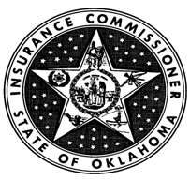

INSURANCE COMMISSIONER STATE OF OKLAHOMA

APPLICATION TO BE AN APPROVED SURPLUS LINES CARRIER IN OKLAHOMA

Whereas, the ,(company) located in the city of in the State of , hereby request approval to be an authorized Surplus Lines Carrier in the State of Oklahoma for the year and agrees, under the signature of its President and Secretary, hereto attached, and the corporate seal of the said Company, that after receiving authority so to do from the Insurance Commissioner of the State of Oklahoma it will transact liability lines of business, currently authorized, and currently transacting in its state of domicile.

IN WITNESS WHEREOF, We have hereto subscribed our names and affixed the corporate seal of the

Company, this day of , 20 .

, President

, Secretary

(Seal)

Revised 01/20

400 N.E. 50th Street, Suite 100 ♦ Oklahoma City, OK 73105
In State Toll Free 800-522-0071 ♦ (405) 521-3966 ♦ Fax (405) 522-4160

